Pre-requisite:

1. Install Cassandra db on machine.

Guide used:

https://www.youtube.com/watch?v=hJxlkHafYsQ

Installing Apache Cassandra on Windows in 2021

Download links and version used.

1. python

https://www.python.org

https://www.python.org/downloads/windows/

python-2.7.18.amd64

Python 2.7.18 - April 20, 2020

- **Windows x86-64 MSI installer**

2. openjdk

https://adoptopenjdk.net - prebuilt openjdk

https://adoptium.net/temurin/releases/?os=windows&package=jdk&version=8

**(msi)** OpenJDK8U-jdk_x64_windows_hotspot_8u382b05

3. cassandra

https://cassandra.apache.org/download/

apache-cassandra-3.11.16-bin.tar

https://archive.apache.org/dist/cassandra/3.11.10/

https://archive.apache.org/dist/cassandra/3.11.16/

4. 7-zip

https://www.7-zip.org/

7z2301-x64

1. install python

Note: on installation "Customize Python.." – set the “Add python .exe to path”

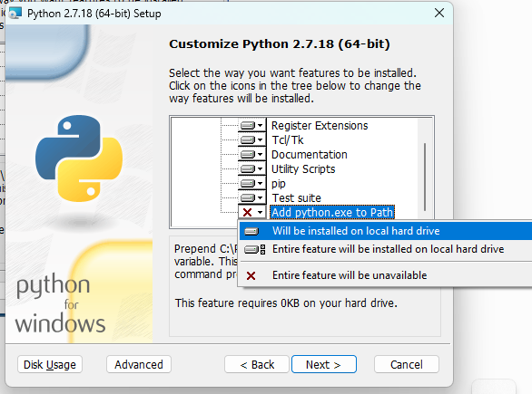

2. Install openjdk

Note: enable the JAVA_HOME

Verify JAVA_HOME in environment variables if set.

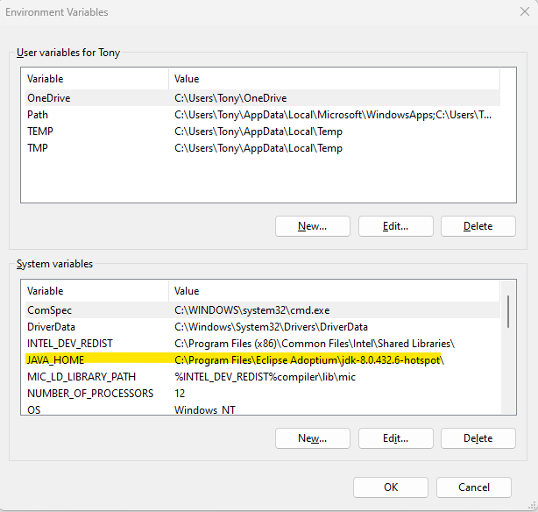

Verify Path, bin and python paths were defined. If not existing, you can insert value by click “New”, and map the target path.

3. install cassandra.

Install 7zip

Right click on “apache-cassandra-3.11.16-bin.tar.gz”, select 7-zip, extract to here.

Extract the .tar file and set the extracted data into “C: \”, and uncheck the path for bin file

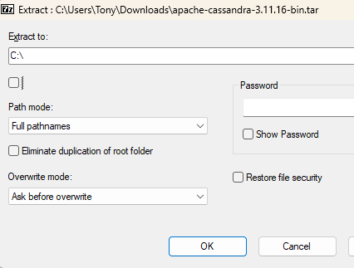

it has “bin” and “conf” folders. bin – where you run your commands

Testing

1. Open CMD
2. Map to C:\apache-cassandra-3.11.16\bin

1. Typein – “cassandra”

The program exits – wherein it should be running. Fix error messages.

1. For error –

Set windows powershell admin, and change policy

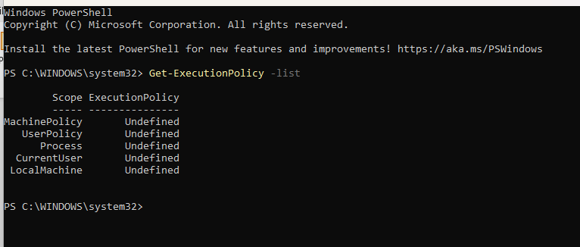

Note: we want the LocalMachine to be allowed.

Press Enter, then Y

LocalMachine is now unrestricted.

1. For Error

Close cmd - cassandra

Change the cassandra configuration - C:\apache-cassandra-3.11.16\conf, and check on “cassandra-env”

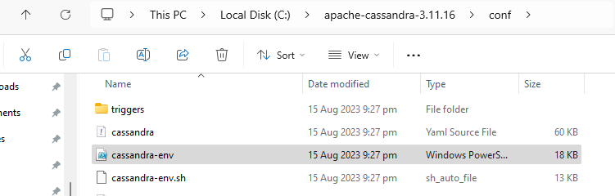

View – Option – uncheck the “Hide extensions for known file types”.

It will now show as .ps1 (powershell) file

Open the file cassandra-env.ps1 (with notepad++) the go to line 357

Comment out 357 – since not necessary, Save and close



1. Open CMD – cassandra bin again, and type in “cassandra” then hit enter – and see if it runs now.

The prompt is not terminated and seems running.

To test – open another CMD – and mapped to cassandra bin.

Type in command “nodetool status” – this will return the current running instance status

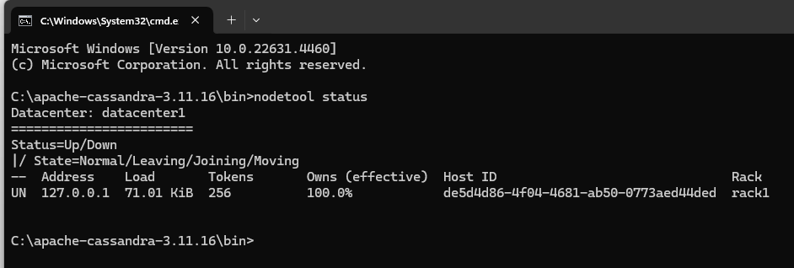

This shows status of 1 node – up and running

Try using “cqlsh” – cassandra query language

Note: fix the “pyreadline dependency missing”

Type in “quit”, press “enter” then type in “pip install pyreadline” then press enter

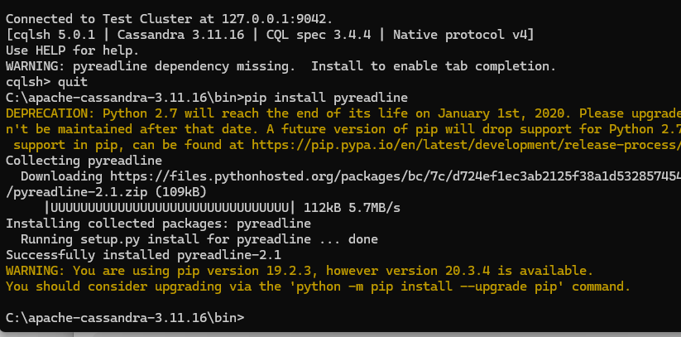

Perform also the suggestion “python -m pip install --upgrade pip”

Type in “cls” – to clear the screen, press enter, then type in “cqlsh” then press enter

Notice: warning messages is now gone

Type in – “quit” to close the cqlsh session

Note:

HEAP Settings/Memory – can be set in “jvm.options” file – in C:\apache-cassandra-3.11.16\conf

Timestamp: 16:10

